Group 2

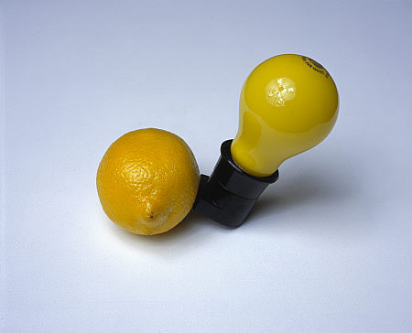
Joseph Beuys; Capri Batterie; 1985; Yellow light bulb in black socket, lemon; 18.5 x 18.5 x 18.5 cm

- How are the meanings of the objects changed when placed in a new context?
- What do you think is the purpose of the work?
- Who do you think is the intended audience?
- What skills do you think were involved in making this work?
- Why do you think these particular objects were used?
- What is the relationship between the objects?
- Do you think the objects have a history in the artist’s life?
- How do the objects that were used shape the overall message/effect of the piece?
- What is the purpose of using found objects to make sculpture as opposed to conventional materials like clay, metal, or wood?

